WEEK5

Q)Writeaprogramthatprintsasimplechessboard.

Inputformat:

Thefirstlinecontainsthenumberofinputs T.

Thelinesafterthatcontainadifferentvaluesforsizeofthechessboard Output format:

Printachessboardofdimensionssize\*size.PrintaPrintWforwhitespaces andB forblack spaces.

Input: 2

3

5

Output:

WBW BWB WBW WBWBW BWBWB WBWBW BWBWB WBWBW

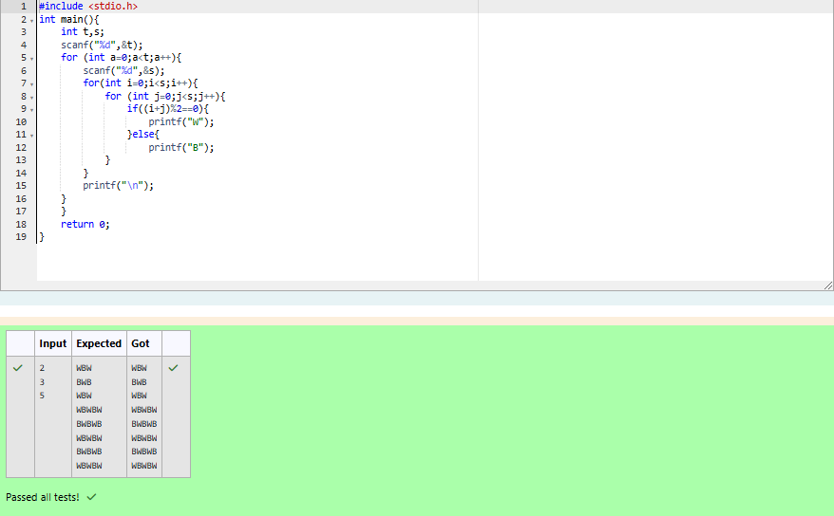

Q)Let’sprintachessboard!

Writeaprogramthattakesinput:

ThefirstlinecontainsT, thenumberoftestcases

EachtestcasecontainsanintegerNandalsothestartingcharacterofthe chessboard Output Format

Printthechessboardasperthegivenexamples Sample Input / Output

Input: 2

2 W

3 B

Output: WB

BW BWB WBW BWB

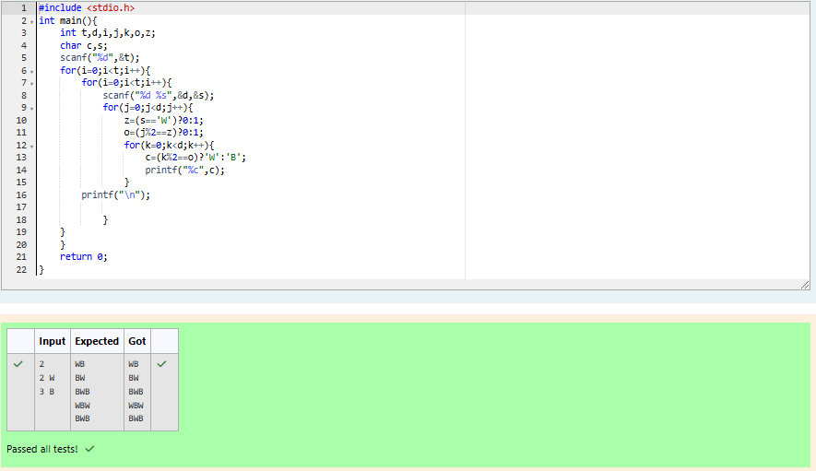

Q)DecodethelogicandprintthePatternthatcorrespondstogiveninput.

IfN= 3

thenpatternwillbe: 10203010011012

\*\*4050809

\*\*\*\*607

IfN=4,thenpatternwillbe: 1020304017018019020

\*\*50607014015016

\*\*\*\*809012013

\*\*\*\*\*\*10011

Constraints

2<= N <= 100

InputFormat

FirstlinecontainsT,thenumberoftestcases Each test case contains a single integer N Output

FirstlineprintCase#iwhereiisthetestcasenumber In the subsequent line, print the pattern

TestCase1

3

3

4

5

Output

Case#1

10203010011012

\*\*4050809

\*\*\*\*607

Case#2

1020304017018019020

\*\*50607014015016

\*\*\*\*809012013

\*\*\*\*\*\*10011

Case#3

102030405026027028029030

\*\*6070809022023024025

\*\*\*\*10011012019020021

\*\*\*\*\*\*13014017018

\*\*\*\*\*\*\*\*15016

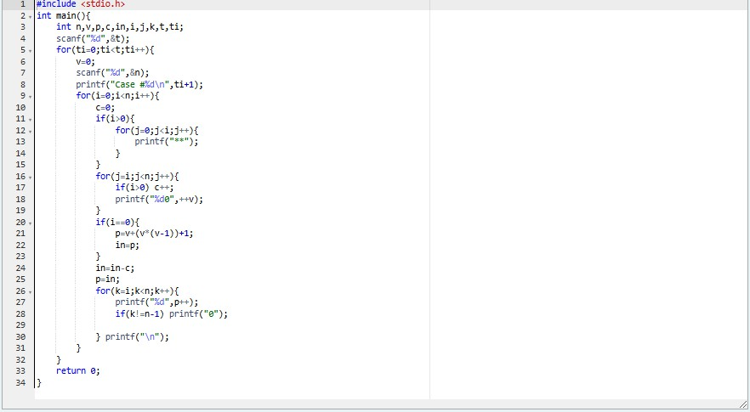

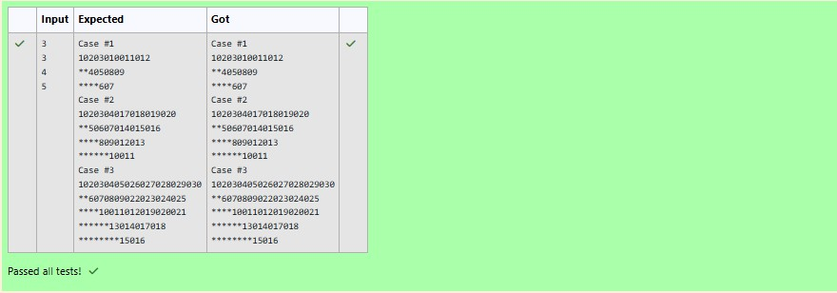

Q) Thek-digitnumberNisanArmstrong numberifandonlyifthek-thpowerofeachdigit sums to N.

GivenapositiveintegerN,returntrueifandonlyifitisanArmstrongnumber. Example 1:

Input:

153

Output:

true Explanation:

153isa3-digitnumber,and153=1^3+5^3+3^3. Example 2:

Input:

123

Output:

false Explanation:

123isa3-digitnumber,and123 !=1^3+2^3+ 3^3=36.

Example3: Input:

1634

Output:

true Note:

1<= N <= 10^8

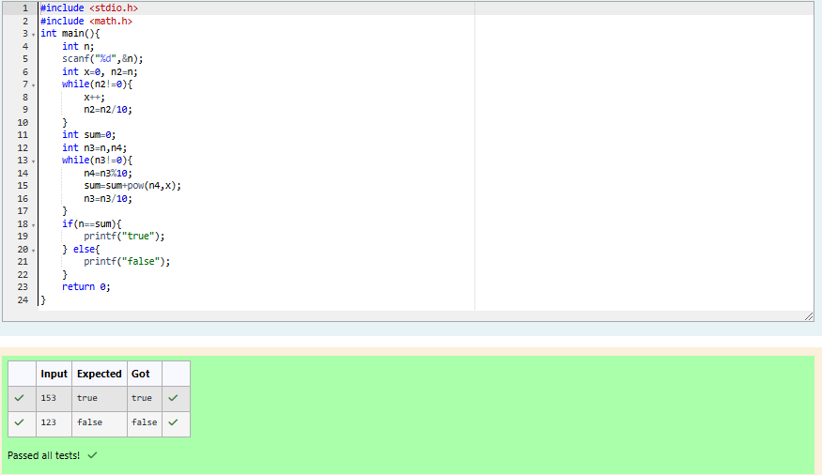

Q)Take a number, reverse it and add it to the original number until theobtainednumberisapalindrome.Constraints1<=num<=99999999SampleInput 1 32 Sample Output1 55

SampleInput2789SampleOutput266066

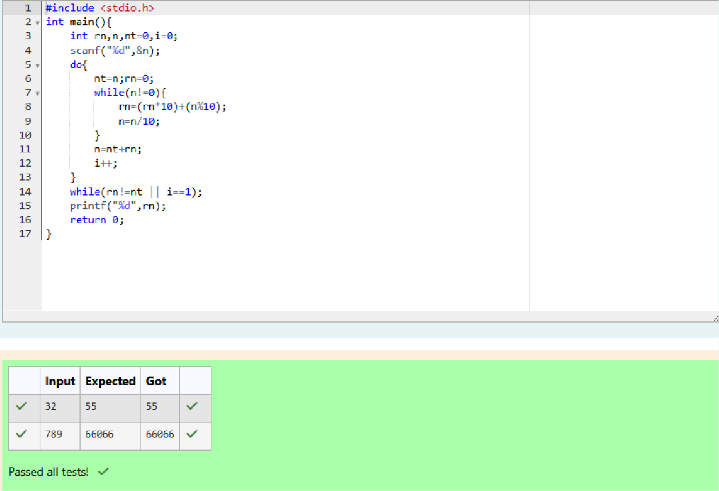

Q) A number is considered lucky if it contains either 3 or 4 or 3 and 4 both in it. Write a program to print the nth lucky number. Example, 1st lucky numberis 3,and2ndluckynumberis4and3rdluckynumberis33and 4th lucky number is 34 and so on. Note that 13, 40 etc., are not lucky as they have other numbers in it.

Theprogramshouldacceptanumber 'n'asinputanddisplaythenthlucky number as output.

SampleInput1:

3

SampleOutput 1:

33

Explanation:

Heretheluckynumbersare3,4,33,34.,andthe3rdluckynumberis33.

SampleInput2:

34

SampleOutput 2:

33344

